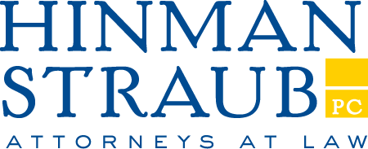

121 State Street
Albany, New York 12207-1693
Tel: 518-436-0751
Fax: 518-436-4751

March 21, 2024

RE: AN ACT to amend the public health law, in relation to prohibiting approved organizations in the child health insurance plan from limiting the participation of certain health care providers

S.4922 (Sepulveda)

MEMORANDUM IN OPPOSITION

Submitted on behalf of the Blue Cross and Blue Shield Plans

The New York State Conference of Blue Cross and Blue Shield Plans strongly opposes the enactment of this legislation, which would prohibit health plans administering the Child Health Plus (“CHP”) program from requiring that participating health care providers accept all products offered by that health plan. Specifically, this bill would allow health care providers to pick and choose which programs they wish to participate in based on a product’s reimbursement rates. Allowing this sort of cherry-picking by providers would undermine the health care networks that are viewed as “undesirable” and disrupt care for children who move from CHP to other coverage due to changes in their eligibility.

This same bill was vetoed by the Governor in 2021. In her Veto Message, the Governor noted that Child Health Plus networks are monitored by the Department of Health for network adequacy upon initial approval and then continuously after that to ensure compliance with network and access requirements. Allowing health plans to require providers to join all networks has not detrimentally impacted the CHP networks. The Veto Message noted that this limitation would have the unintended consequence of causing narrower networks in the commercial market.

Even more concerning, the Veto Message highlighted that this bill would set a precedent that could threaten patients in all programs by allowing providers to favor participation in only plans with higher reimbursement. This bill would endorse that position, encouraging providers to seek out participation in only these higher paying networks.

Further, children in commercial and Medicaid Managed Care coverage would be detrimentally impacted by this bill, as this cherry-picking would leave these children with fewer options for care. This bill would also disrupt care when children move between CHP, Medicaid, and commercial coverage. The continuity of these networks allows children to continue to receive care from the same providers even as they shift between coverages due to eligibility changes, which happens frequently. Allowing providers to only participate in CHP would force families to locate new health care providers when they move from CHP to Medicaid Managed Care or commercial coverage.

For the foregoing reasons, the New York State Conference of Blue Cross and Blue Shield Plans strongly opposes enactment of this legislation.

Respectfully submitted,

HINMAN STRAUB ADVISORS, LLC
Legislative Counsel for the Blue Cross and Blue Shield Plans

4884-5573-7516, v. 1

2021 N.Y. A.B. 1523, S.B. 2212.
Veto Message No. 51 of 2021.
Id.
Id.

