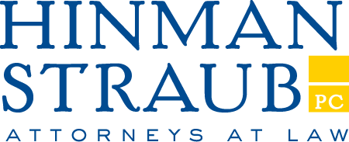

121 State Street
Albany, New York 12207-1693
Tel: 518-436-0751
Fax: 518-436-4751

February 26, 2024

RE: AN ACT to amend the public health law and the insurance law, in relation to providing that the failure by the utilization review agent to make a determination within certain time periods shall be deemed to be an approval of the health care services

A.6898 (Weprin)
S.3402 (Breslin)

MEMORANDUM IN OPPOSITION

Submitted on behalf of the Blue Cross and Blue Shield Plans

The New York State Conference of Blue Cross and Blue Shield Plans strongly opposes enactment of this legislation, which would trigger the automatic approval of health care services if the initial utilization review (“UR”) was not completed on time.

This legislation would force health plans to cover such services, regardless of whether they are clinically appropriate, if the plan or its UR agent fails to meet an administrative timeframe for rendering a determination on whether a service is medically necessary. While plans and their UR agents endeavor to timely complete reviews and are subject to stringent oversight regarding their UR program implementation, in processing millions of claims per year, deadlines are occasionally and inadvertently missed. Current state law treats the failure of a UR agent to make a determination within the initial review timeframe as an adverse determination, subject to internal, and ultimately, external appeal. If this occurs, an enrollee or the enrollee’s health care provider may file an internal appeal without delay. This process ensures that the appropriate medical necessity determination is made by the plan and when coverage is warranted.

The existing system strikes a logical balance by deeming any UR that is not timely completed an adverse determination, while permitting reconsideration and appeal of that determination. By allowing providers such latitude, while denying plans a similar ability to appeal, this bill would upset a harmonious and congruent system. Further, automatically approving services simply because a UR agent misses an administrative deadline by a matter of hours would be imprudent and counter to sound health care policy, as enrollees may receive treatments and services inappropriate for their needs. This medically unnecessary care would result in increased costs that will be felt by consumers and employers through premium increases.

For the foregoing reasons, the New York State Conference of Blue Cross and Blue Shield Plans opposes this bill and urges that it not be enacted.

Respectfully submitted,

HINMAN STRAUB ADVISORS, LLC.
Legislative Counsel for the Blue Cross and Blue Shield Plans of New York

4870-0057-9236, v. 1

N.Y. Insurance Law § 4903(g) and N.Y. Public Health Law § 4903(7).

